
Serving more than 1.8 million people in 117 of 120
Kentucky counties, Kentucky’s member-owned electric
cooperatives are committed to improving the quality
of life for their consumer-members. We encourage
Kentuckians to engage with elected leaders and
advocate for safe, reliable and affordable electricity.
www.kyelectric.coop
GUIDE
KENTUCKY ELECTRIC COOPERATIVES
LEGISLATIVE

2026

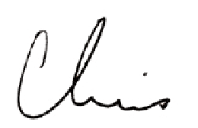
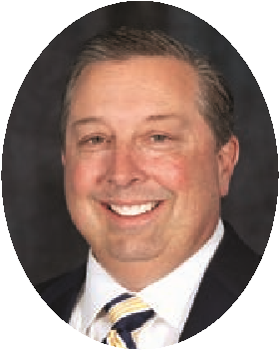
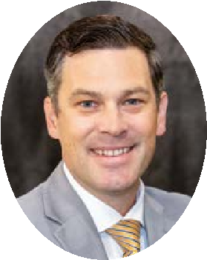
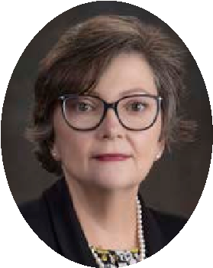
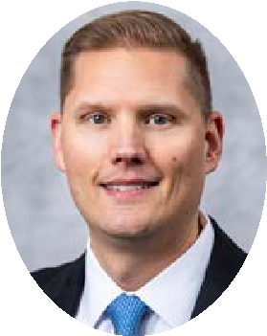
This 2026 Legislative Guide is provided as a public service by Kentucky Electric Cooperatives, the statewide association representing the 26 co-ops who serve more than 1.8 million Kentuckians in 117 of the commonwealth’s 120 counties. Electric cooperatives are locally owned and controlled by the consumer-members we serve. There are no out-of-town shareholders. Co-ops are dedicated to providing safe and reliable electricity at the lowest possible cost. To help protect that mission, we engage with elected leaders and regulators on behalf of our members.
We appreciate the service of elected leaders and are especially grateful to those who reflect co-op values and priorities–in particular, the members of the Kentucky Rural Electric Cooperatives Caucus, which is the largest of any official caucus according to the Legislative Research Commission.
To stay up to date and communicate with legislators, join our grassroots portal, RuralPowerKY.com. Save this guide and use it to contact elected leaders about issues that are important to you.
Chris Perry
President/CEO
ON THE COVER: Dedicated in 1961 by Gov. Bert T. Combs, the Floral Clock keeps time on the
West Lawn of the Capitol grounds. Photo: Visit
Frankfort
KENTUCKY’S ELECTRIC COOPERATIVES ARE ADVOCATES FOR THEIR CONSUMER-MEMBERS.
- Kentucky’s electric cooperatives belong to and are led by the local members in the communities they serve.
- The priorities of not-for-profit co-ops align directly with the needs of the community. There are no outside investors.
- Co-op decisions are made locally with a focus on reliable service delivered as safely and cost-effectively as possible.
- Co-ops prioritize initiatives that improve quality of life, such as economic development and broadband access.

KENTUCKY ELECTRIC CO-OP ADVOCACY TEAM
Chase C. Crigler
Vice President Government Affairs
Kentucky Electric Cooperatives (502) 815-6305 ccrigler@kyelectric.coop
Talina Matthews
Chief Financial Officer
Big Rivers Electric Corporation (270) 844-6194 talina.mathews@bigrivers.com
Eric Landis
Director of Legislative and Government Relations
East Kentucky Power Cooperative (859) 745-9255 eric.landis@ekpc.coop

RuralPowerKY.com
Speak up for local co-ops and stay informed on the issues affecting your co-op service by joining our grassroots network at RuralPowerKY.com

KENTUCKY CONSTITUTIONAL OFFICES | KENTUCKY CONGRESSIONAL DELEGATION
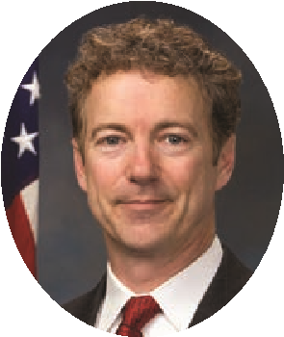
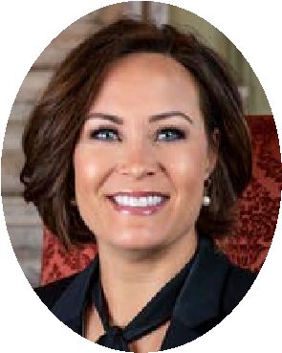
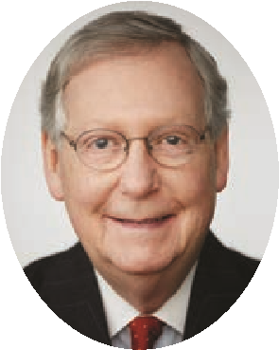
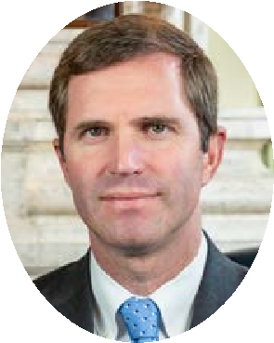
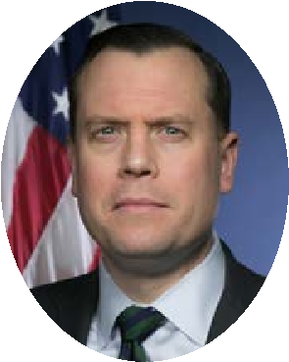
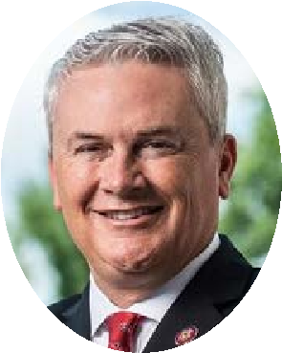
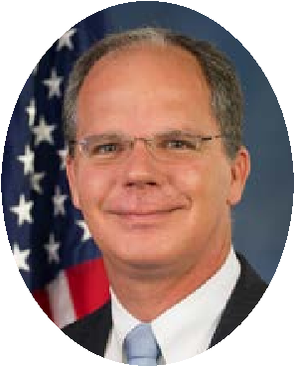
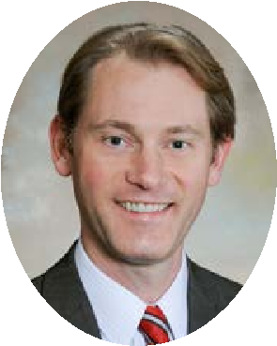
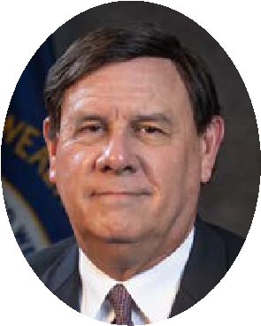
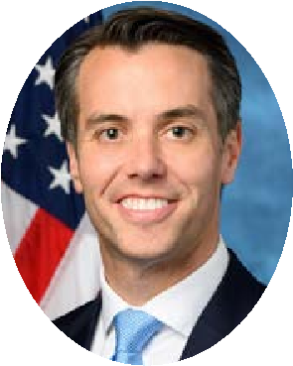
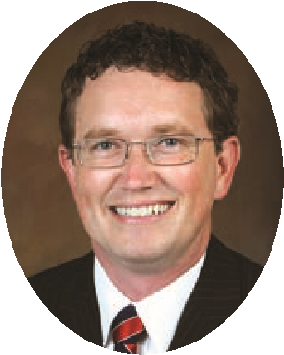
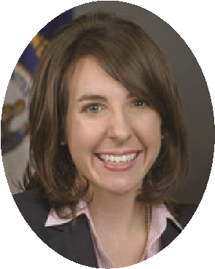
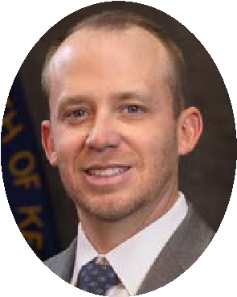
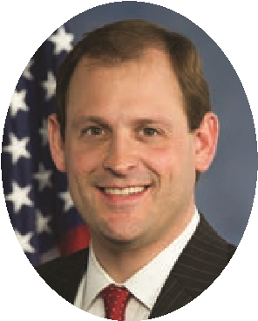
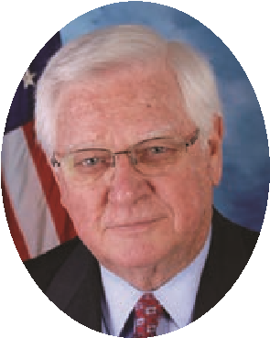
Andy Beshear Jacqueline ColemanSen. Mitch McConnell Sen. Rand Paul
Governor Lt. Governor (202) 224-2541 (202) 224-4343
(502) 564-2611 (502) 564-2611
Russell Coleman Michael Adams Rep. James Comer Rep. Brett Guthrie
Attorney General Secretary of State 1st District 2nd District
(502) 696-5300 (502) 564-3490(202) 225-3115 (202) 225-3501
Allison Ball Mark MetcalfRep. Morgan McGarvey Rep. Thomas Massie
Auditor Treasurer 3rd District 4th District
(502) 564-5841 (502) 564-4722(202) 225-5401 (202) 225-3465
Jonathan Shell Rep. Harold “Hal” Rogers Rep. Andy Barr
Comm. of Agriculture 5th District 6th District
(502) 573-0282(202) 225-4601 (202) 225-4706
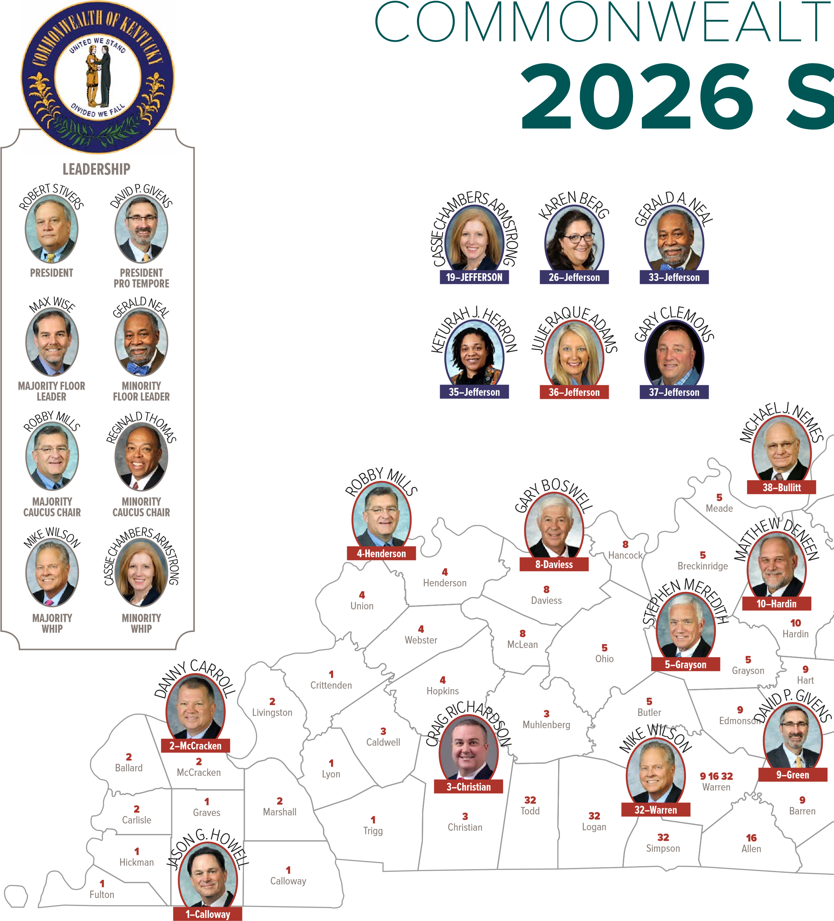

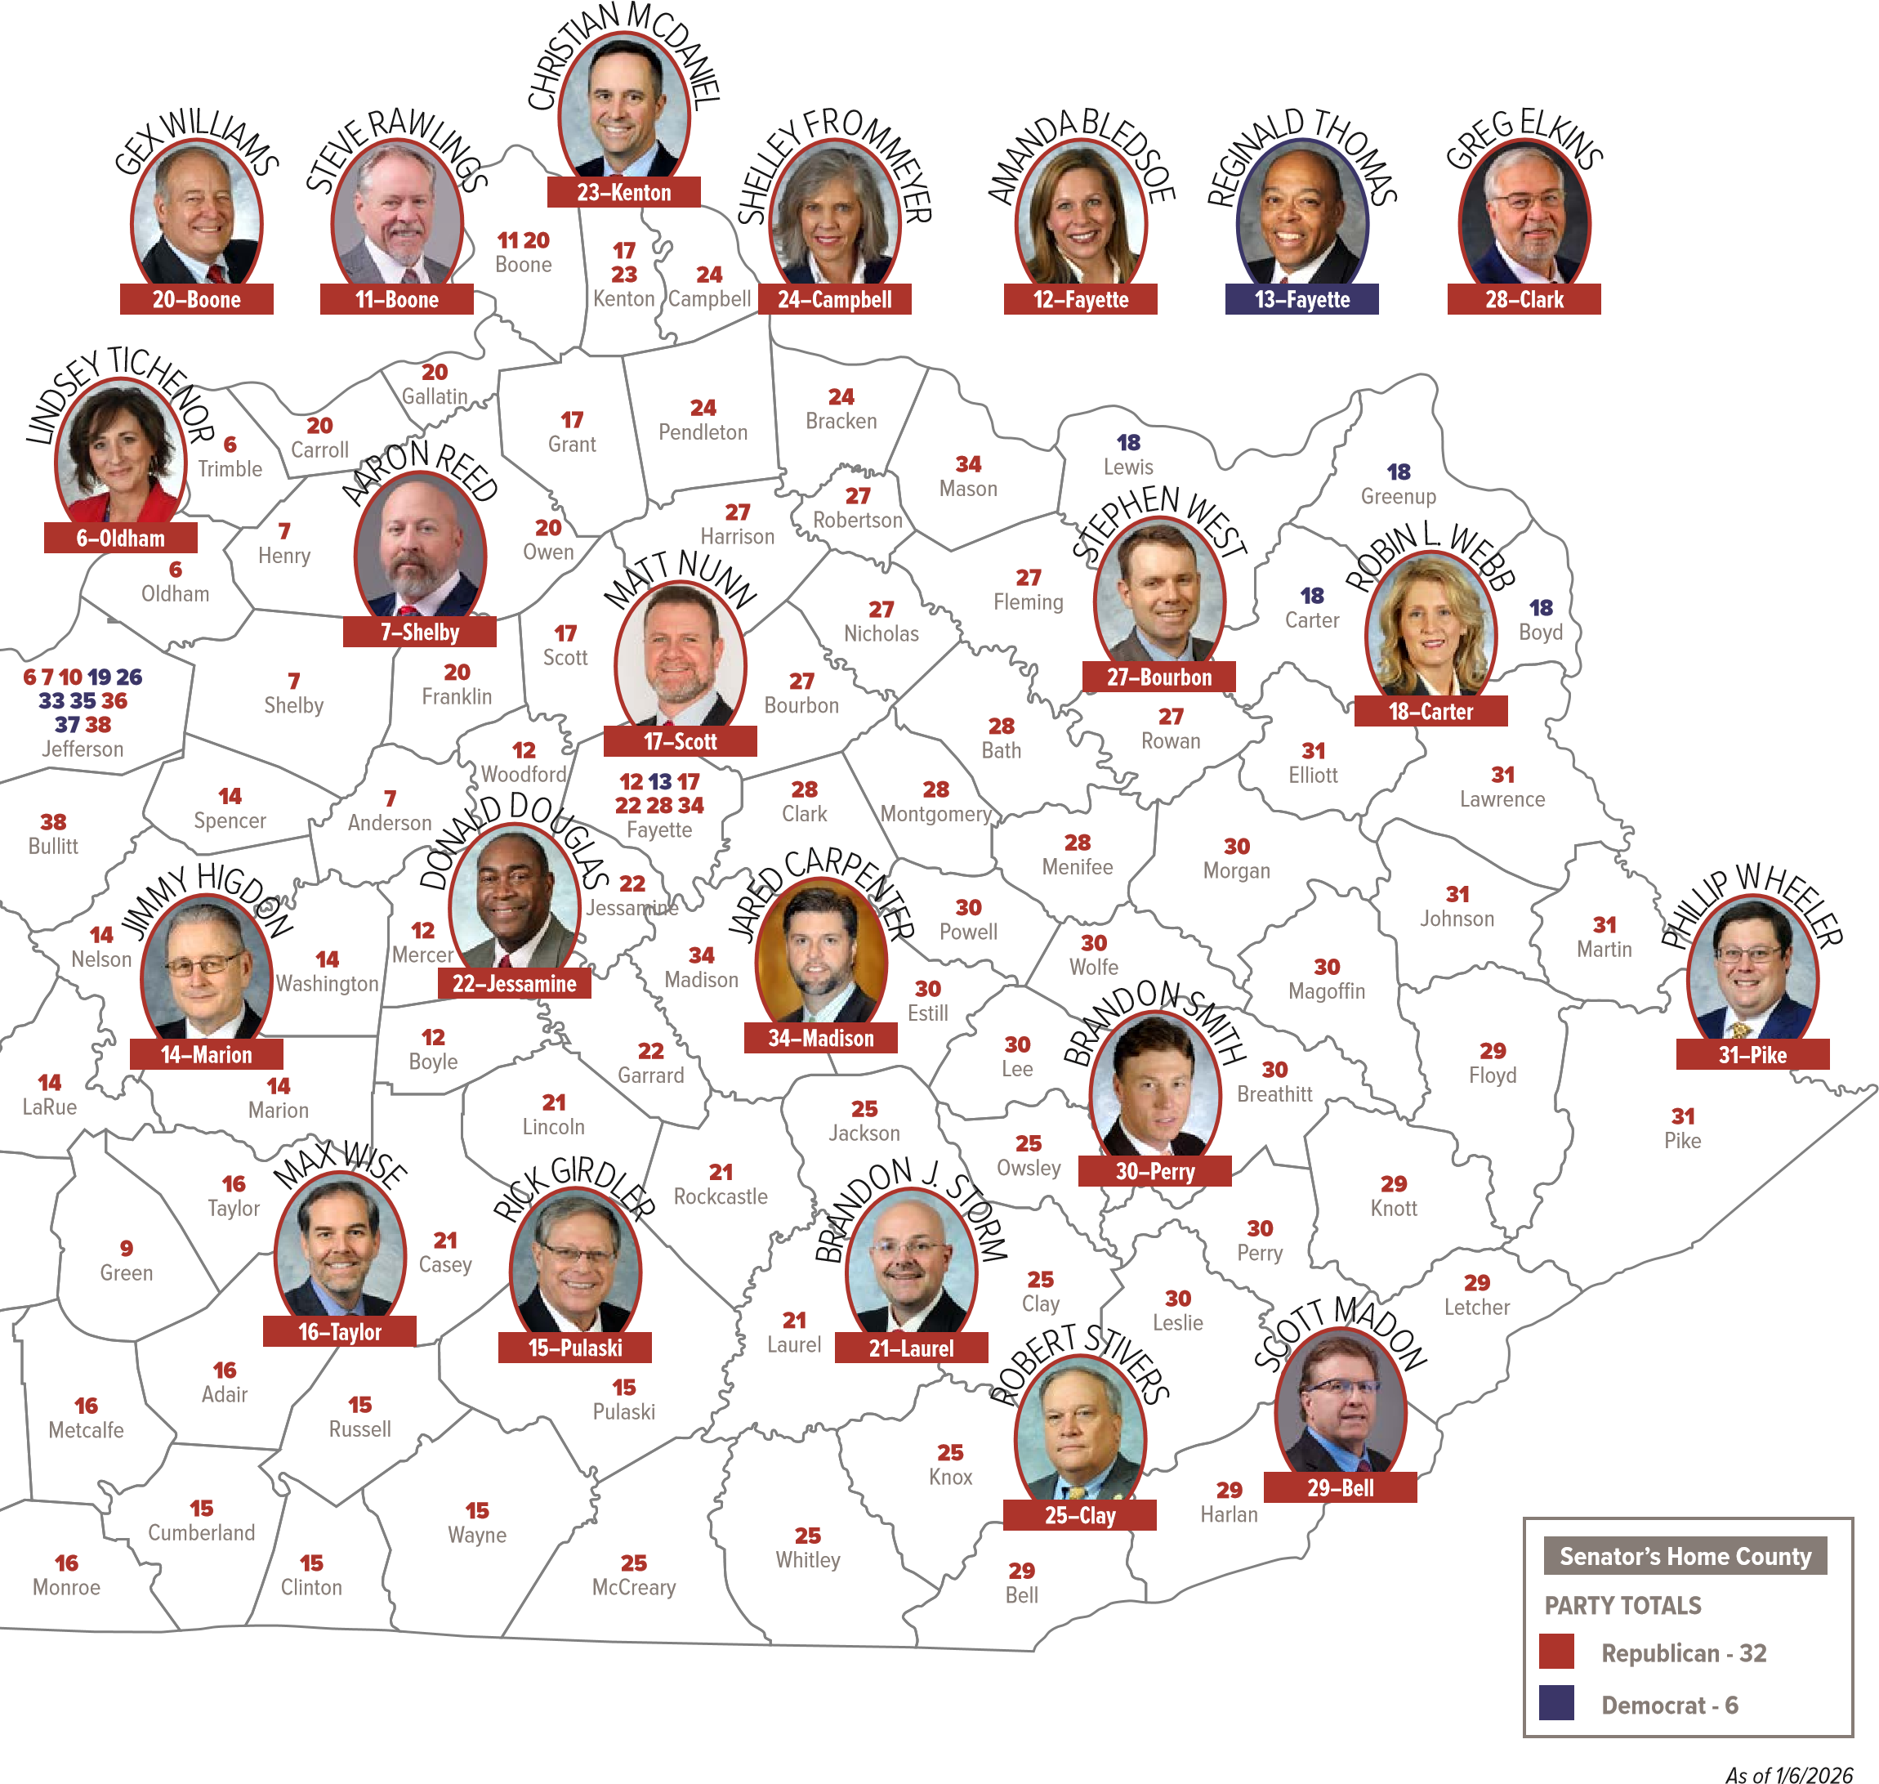
H OF KENTUCKY SENATE
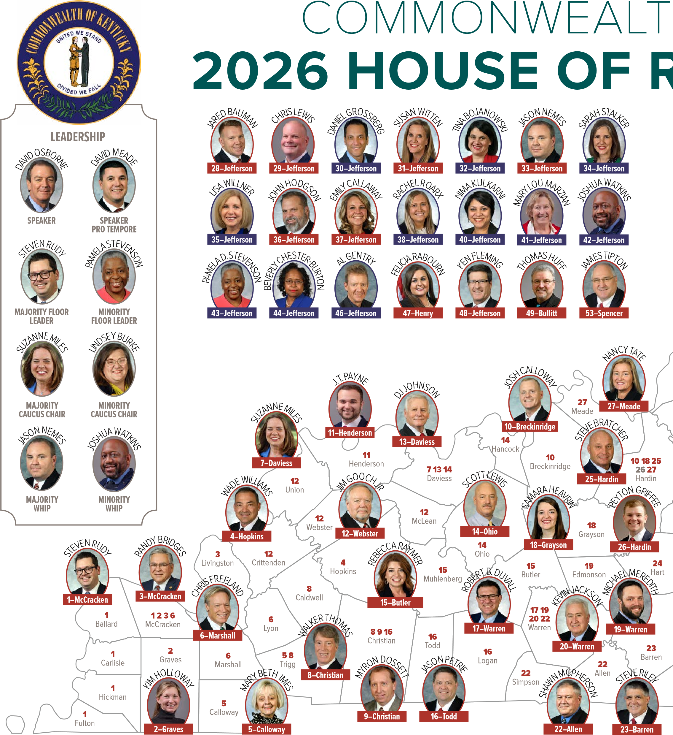

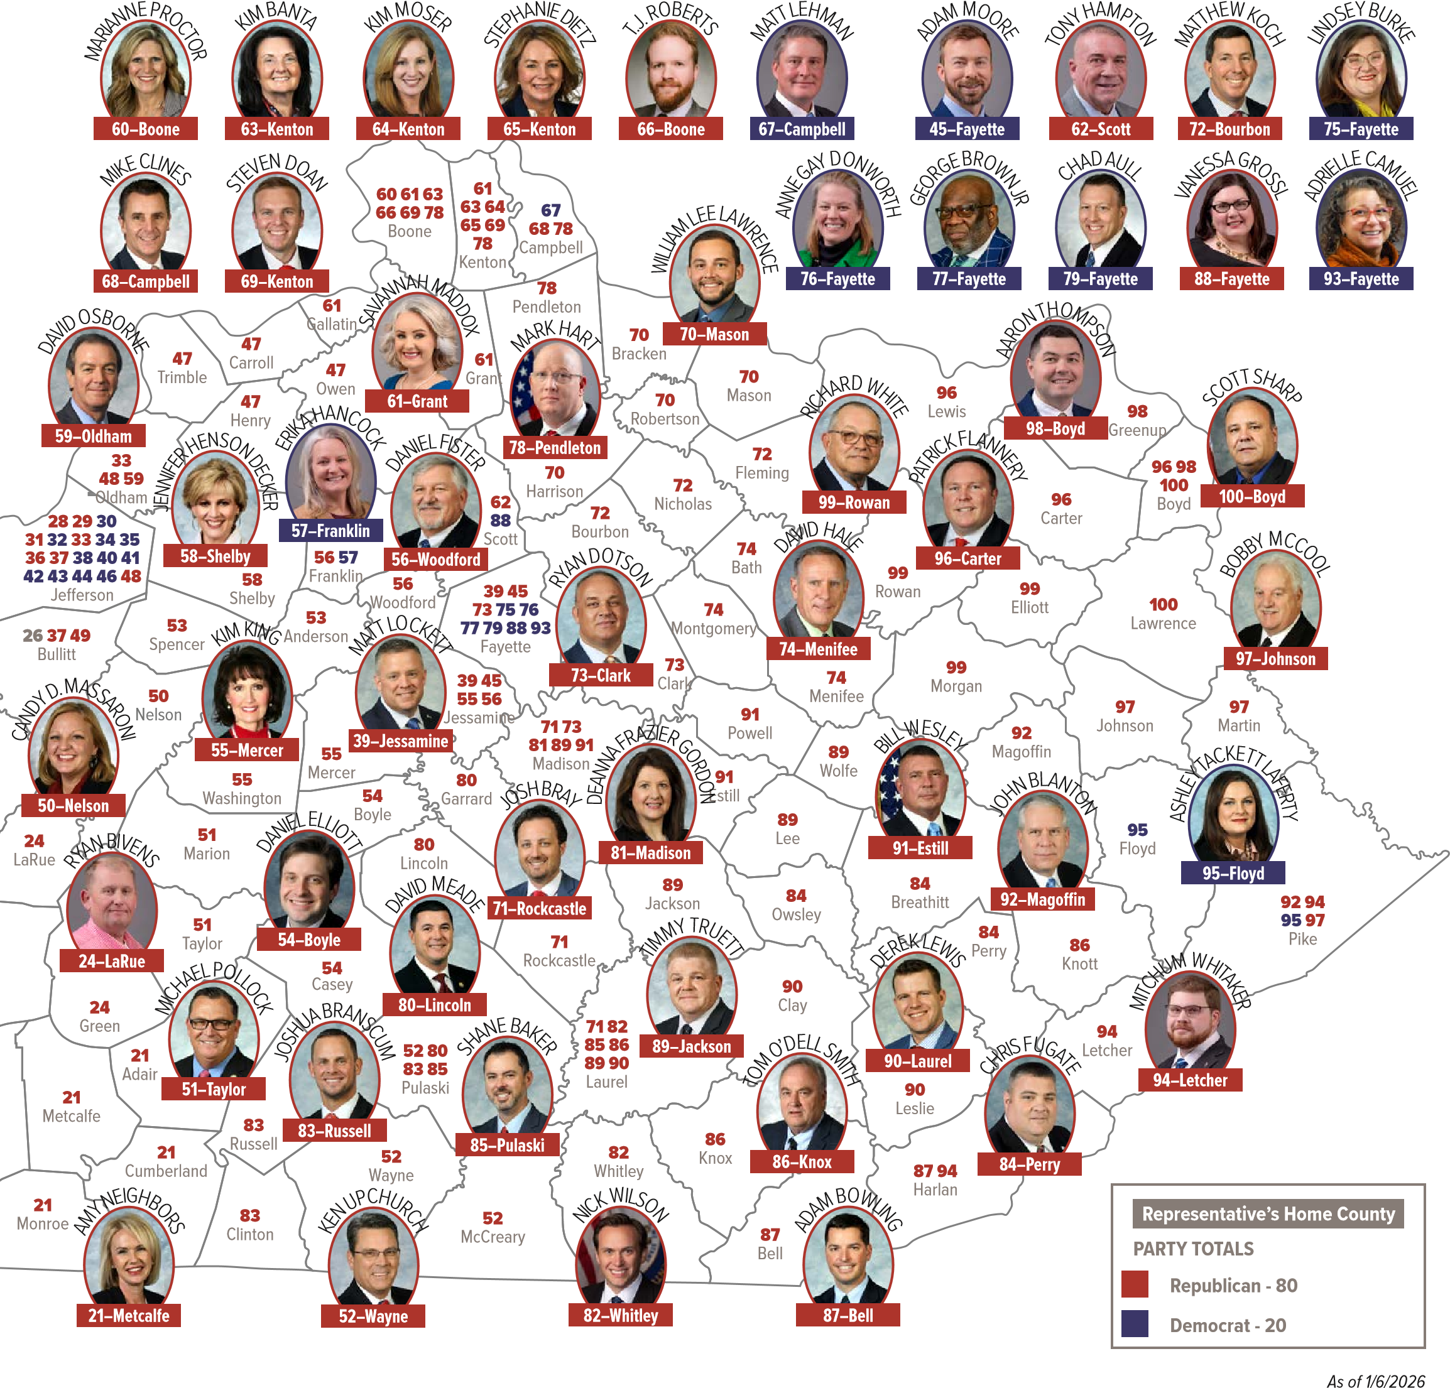
H OF KENTUCKY REPRESENTATIVES
IN APPRECIATION TO MEMBERS OF THE
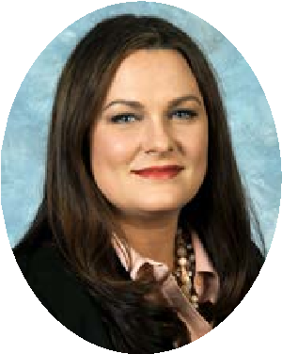
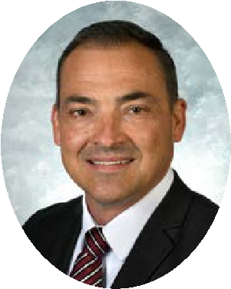
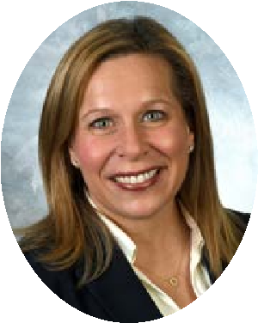
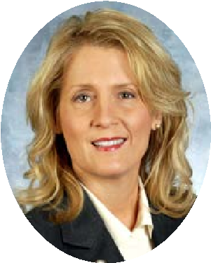
KENTUCKY RURAL ELECTRIC COOPERATIVES CAUCUS

CAUCUS

CO-CHAIRS
Sen. Amanda Mays Bledsoe Sen. Robin L. Webb
Rep. Ashley Tackett Laferty
Rep. Wade Williams
THANK YOUR LEGISLATORS FOR SUPPORTING CO-OPS
We encourage co-op consumer-members to thank their elected officials who demonstrate a commitment to truly serve their local communities and our commonwealth.
Use the QR code at right or visit RuralPowerKy.com to send a thank you note to your senators and representatives who are members of the Rural Electric Cooperatives Caucus. This caucus is a bipartisan group of lawmakers who share a common goal to learn about how electric co-ops work so they can advocate for local co-op priorities
Caucus members receive regular updates and briefings throughout the year and during the
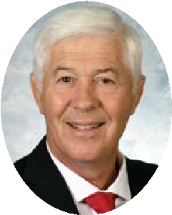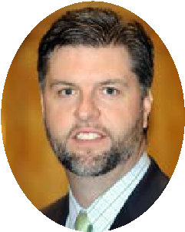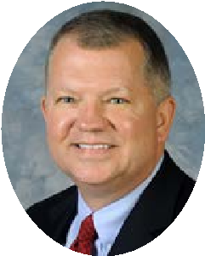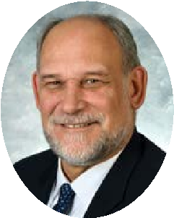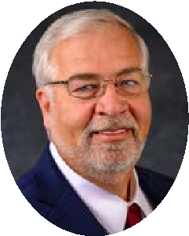
legislative session. They are invited to attend Electric University, hosted by
Kentucky Electric Cooperatives, which offers a deep dive into how electricity
is generated and transmitted to homes and businesses across Kentucky.
Sen. Gary Boswell
Sen. Jared Carpenter
Sen. Danny Carroll
Sen. Matthew
Deneen
Sen. Greg Elkins
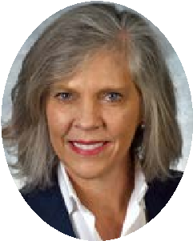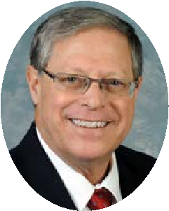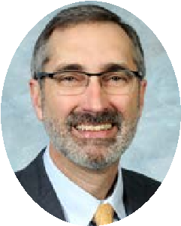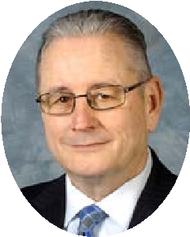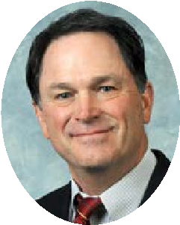
Sen. Shelley Funke Sen. Rick Girdler Sen. David P. Givens Sen. Jimmy Higdon Sen. Jason Howell Frommeyer
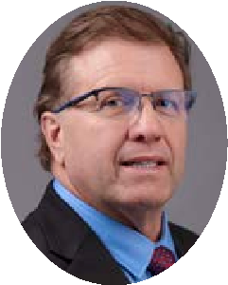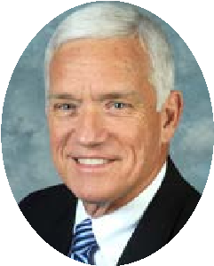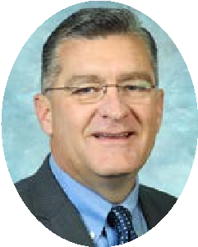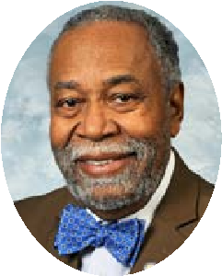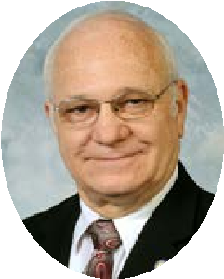
Sen. Scott Madon Sen. Stephen Sen. Robby Mills Sen. Gerald A. Neal Sen. Michael J.
Meredith Nemes

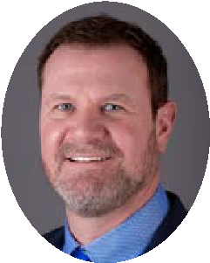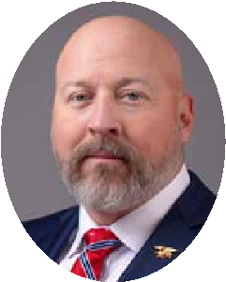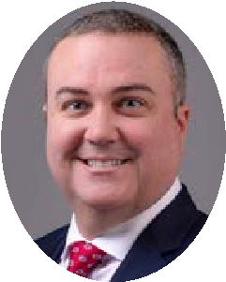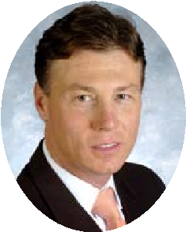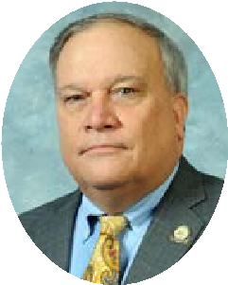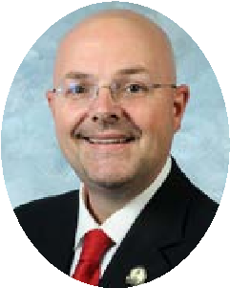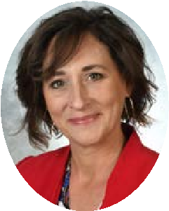
Sen. Matt Nunn
Sen. Aaron Reed
Sen. Craig Richardson
Sen. Brandon Smith
Sen. Robert Stivers
Sen. Brandon J.
Storm
Sen. Lindsey Tichenor
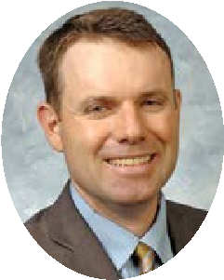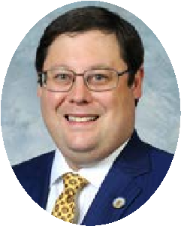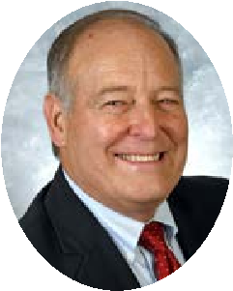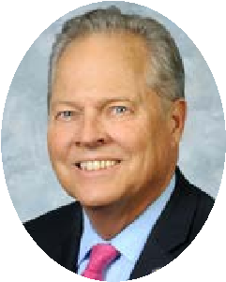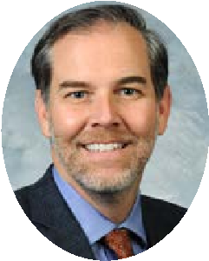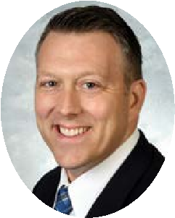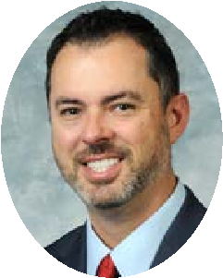
Sen. Stephen West Sen. Phillip Wheeler Sen. Gex Williams Sen. Mike Wilson Sen. Max Wise Rep. Chad Aull Rep. Shane Baker
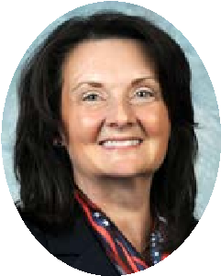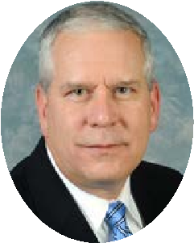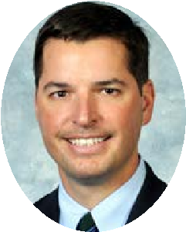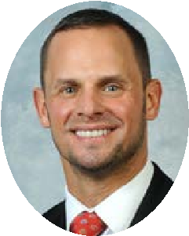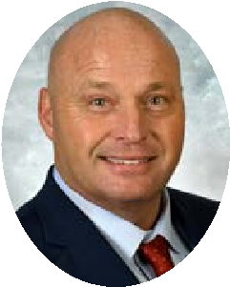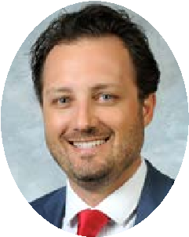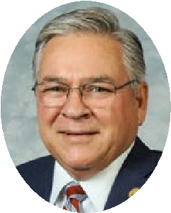
Rep. Kim Banta Rep. John Blanton Rep. Adam Bowling Rep. Josh Branscum Rep. Steve Bratcher Rep. Josh Bray Rep. Randy Bridges
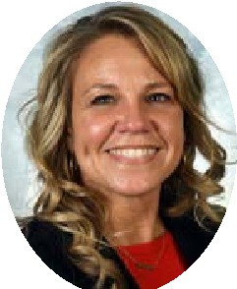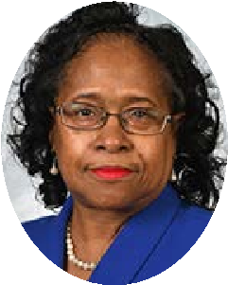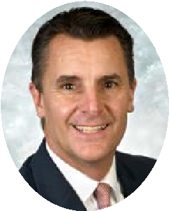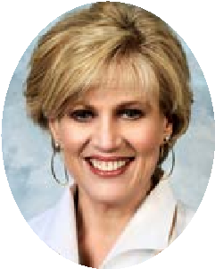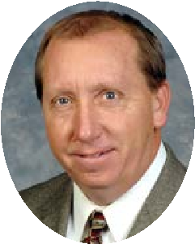
Rep. Emily Callaway Rep. Adrielle Camuel Rep. Beverly Rep. Mike Clines Rep. Jennifer Decker Rep. Stephanie Dietz Rep. Myron Dossett Chester-Burton
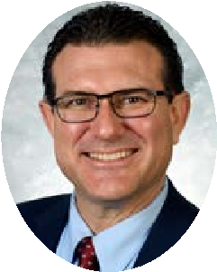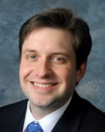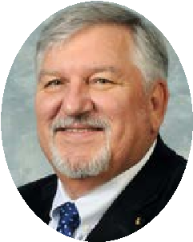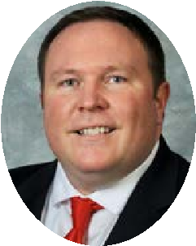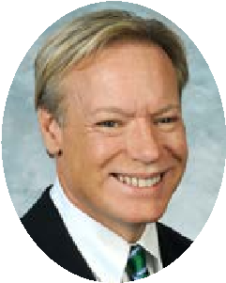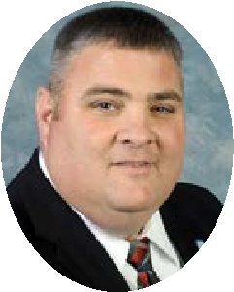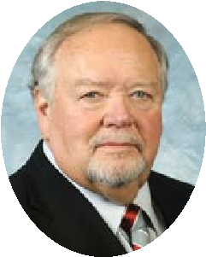
Rep. Robert Duvall Rep. Daniel Elliott Rep. Daniel Fister Rep. Patrick Flannery Rep. Chris Freeland Rep. Chris Fugate Rep. Jim Gooch Jr.
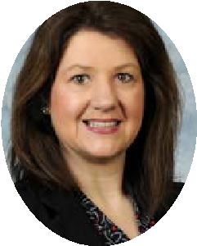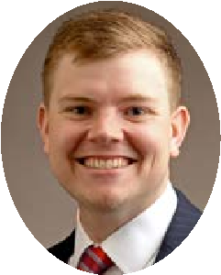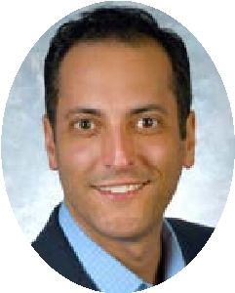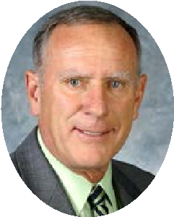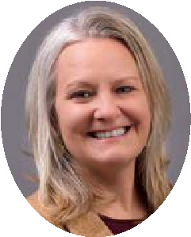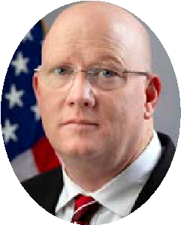
Rep. Deanna Gordon Rep. Peyton Griffee Rep. Daniel Rep. Vanessa Grossl Rep. David Hale Rep. Erika Hancock Rep. Mark Hart
Grossberg

KENTUCKY RURAL ELECTRIC COOPERATIVES CAUCUS (CONT.)
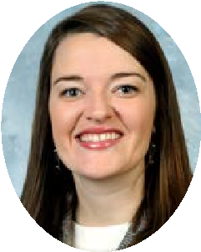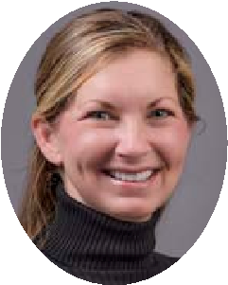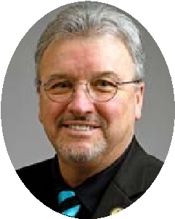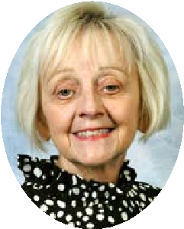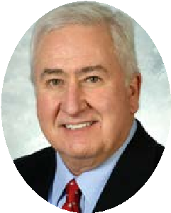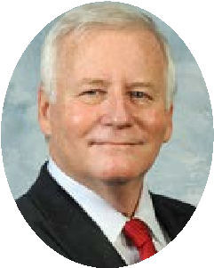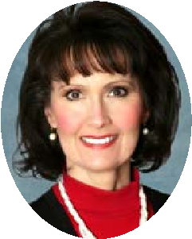
Rep. Samara Heavrin | Rep. Kim Holloway | Rep. Thomas Huff | Rep. Mary Beth Imes | Rep. Kevin Jackson | Rep. DJ Johnson | Rep. Kim King
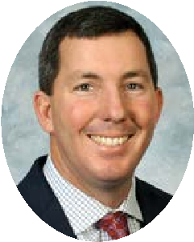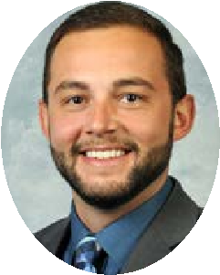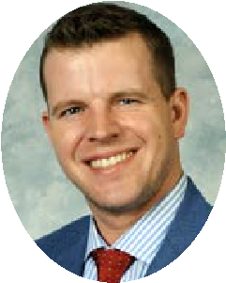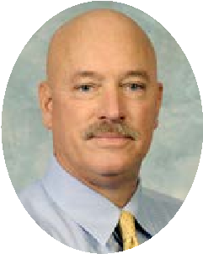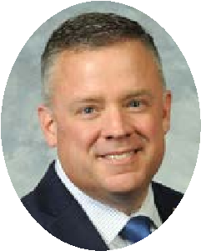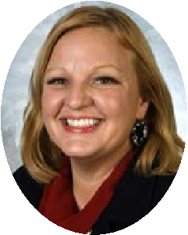
Rep. Matthew Koch | Rep. Nima Kulkarni | Rep. William Lawrence | Rep. Derek Lewis | Rep. Scott Lewis | Rep. Matt Lockett | Rep. Candy Massaroni
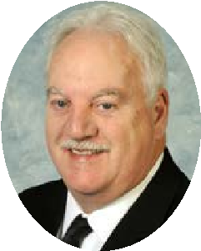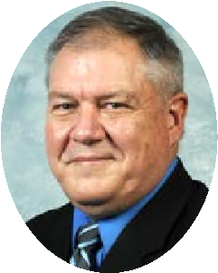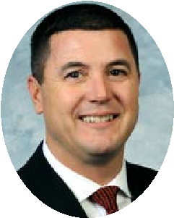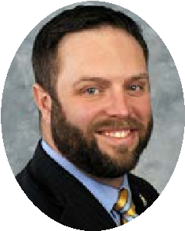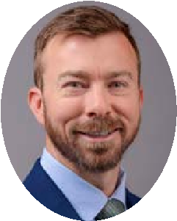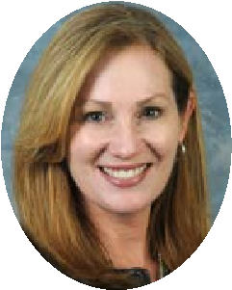
Rep. Bobby McCool | Rep. Shawn McPherson | Rep. David Meade | Rep. Michael Meredith | Rep. Suzanne Miles | Rep. Adam Moore | Rep. Kimberly Poore Moser
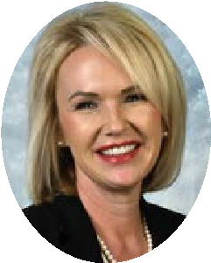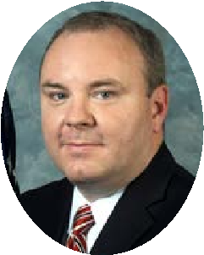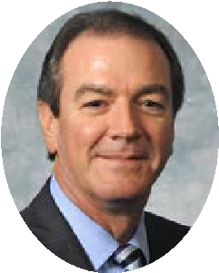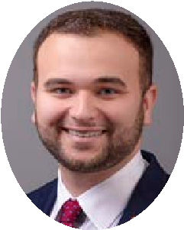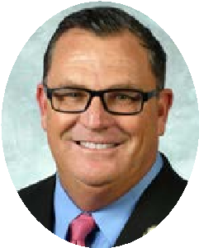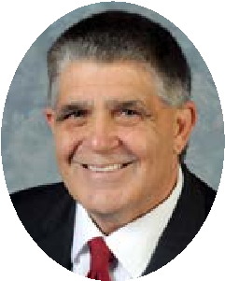
Rep. Amy Neighbors | Rep. Jason Nemes | Rep. David W. Osborne | Rep. JT Payne | Rep. Michael Sarge Pollock | Rep. Rebecca Raymer | Rep. Steve Riley
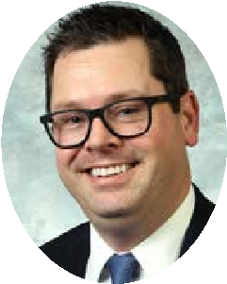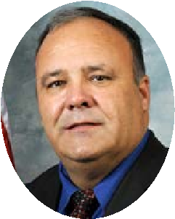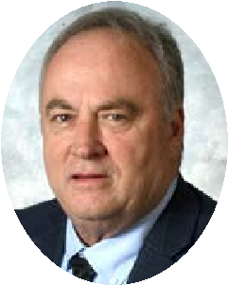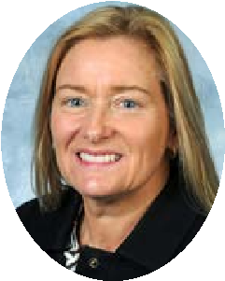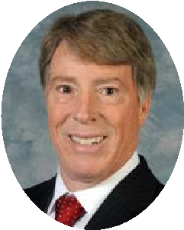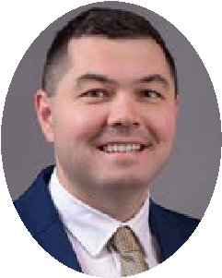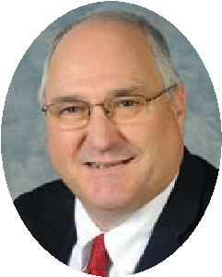
Rep. Steven Rudy | Rep. Scott Sharp | Rep. Tom Smith | Rep. Nancy Tate | Rep. Walker Thomas | Rep. Aaron Thompson | Rep. James Tipton
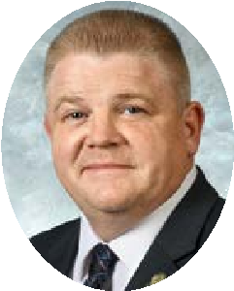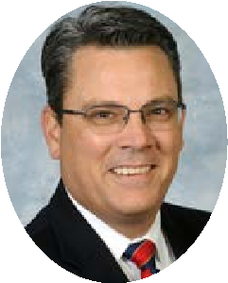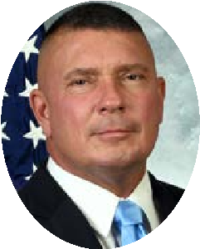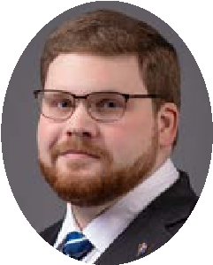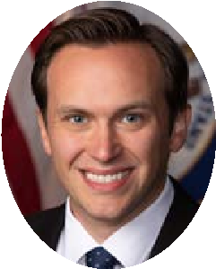
Rep. Timmy Truett Rep. Ken Upchurch Rep. Bill Wesley Rep. Mitch Whitaker Rep. Nick Wilson
Kentucky Rural Electric Caucus membership as of January 6, 2026. Updates to caucus available on RuralPowerKY.com.

STATE SENATORS AND REPRESENTATIVES BY COOPERATIVE
COUNTY REPRESENTATIVE SENATOR |  |  |  | COUNTY REPRESENTATIVE SENATOR
BIG SANDY RECC |  |  |  | BLUE GRASS ENERGY (cont.)
 |  |  |  | Robertson | William Lawrence | Stephen West
 |  |  |  | Scott | Tony Hampton Vanessa Grossl | Matt Nunn
 |  |  |  | Shelby | Jennifer Henson Decker | Aaron Reed
Breathitt | Chris Fugate | Brandon Smith |  | Spencer | James Tipton | Jimmy Higdon
Floyd | Ashley Tackett Laferty | Scott Madon |  | Washington | Kim King | Jimmy Higdon
Johnson | Bobby McCool | Phillip Wheeler |  | Woodford | Daniel Fister | Amanda Bledsoe
Knott | John Blanton | Scott Madon |  | CLARK ENERGY
Lawrence | Scott Sharp | Phillip Wheeler
Magoffin | John Blanton | Brandon Smith
Martin | Bobby McCool | Phillip Wheeler
Morgan | Richard White | Brandon Smith
BLUE GRASS ENERGY |  |  |  | Bath | David Hale | Greg Elkins
 |  |  |  | Bourbon | Matthew Koch | Stephen West
 |  |  |  | Clark | Ryan Dotson | Greg Elkins
 |  |  |  | Estill | Bill Wesley | Brandon Smith
 |  |  |  | Fayette | Ryan Dotson Vanessa Grossl | Greg Elkins
Anderson | James Tipton | Aaron Reed
 |  |  |  | Madison | Deanna Gordon  Timmy Truett  Bill Wesley | Jared Carpenter
Bourbon | Matthew Koch | Stephen West
Bracken | William Lawrence | Shelley Frommeyer
Estill | Bill Wesley | Brandon Smith |  | Menifee | David Hale | Greg Elkins
Fayette | Adrielle Camuel  Ryan Dotson  Vanessa Grossl  Matt Lockett  Adam Moore | Amanda Bledsoe  Jared Carpenter  Donald Douglas |  | Montgomery | David Hale | Greg Elkins
 |  |  |  | Morgan | Richard White | Brandon Smith
 |  |  |  | Powell | Bill Wesley | Brandon Smith
 |  |  |  | Rowan | Richard White | Stephen West
Franklin | Daniel Fister Erika Hancock | Gex Williams |  | CUMBERLAND VALLEY ELECTRIC*
Garrard | David Meade | Donald Douglas
Grant | Savannah Maddox | Matt Nunn
Harrison | William Lawrence | Stephen West
Henry | Felicia Rabourn | Aaron Reed
 |  |  |  | Bell Adam Bowling |  | Scott Madon
Jackson | Timmy Truett | Robert Stivers |  |  |  | Scott Madon
 |  |  |  | Clay Derek Lewis |  | Robert Stivers
Jessamine | Daniel Fister  Kim King  Matt Lockett  Adam Moore | Donald Douglas |  |  |  | Robert Stivers
 |  |  |  | Harlan Adam BowlingMitchum Whitaker |  | Scott Madon
 |  |  |  | Knox Tom O'Dell Smith |  | Robert Stivers
Madison | Josh Bray  Deanna Gordon  Timmy Truett | Jared Carpenter |  | Laurel Tom O'Dell Smith_{Nick Wilson} |  | Brandon Jackson Storm
 |  |  |  | Leslie Derek Lewis |  | Brandon Smith
Mercer | Kim King | Amanda Bledsoe |  |  |  | Brandon Smith
 |  |  |  | Letcher Mitchum Whitaker |  | Scott Madon
Nelson | Candy D. Massaroni | Jimmy Higdon |  |  |  | Scott Madon
 |  |  |  | McCreary Ken Upchurch |  | Robert Stivers
Nicholas | Matthew Koch | Stephen West |  |  |  | Robert Stivers
 |  |  |  | Whitley Nick Wilson |  | Robert Stivers
Pendleton | Mark Hart | Shelley Frommeyer |  |  |  | Robert Stivers
*Also serves Tennessee As of 1/6/2026

STATE SENATORS AND REPRESENTATIVES BY COOPERATIVE
  COUNTY | REPRESENTATIVE | SENATOR
  FARMERS RECC
  Adair | Amy Neighbors | Max Wise
  Barren | Steve Riley | David Givens
  Edmonson | Michael Meredith | David Givens
  Grayson | Samara Heavrin | Stephen Meredith
  Green | Ryan Bivens | David Givens
  Hardin | Samara Heavrin | Matthew Deneen
  Hart | Ryan Bivens | David Givens
  LaRue | Ryan Bivens | Jimmy Higdon
  Metcalfe | Amy Neighbors | Max Wise
  Monroe | Amy Neighbors | Max Wise
  Warren | Michael Meredith | David Givens
  FLEMING-MASON ENERGY
  Bath | David Hale | Greg Elkins
  Bracken | William Lawrence | Shelley Frommeyer
  Fleming | Matthew Koch | Stephen West
  Lewis | Patrick Flannery | Robin Webb
  Mason | William Lawrence | Stephen West
  Nicholas | Matthew Koch | Stephen West
  Robertson | William Lawrence | Stephen West
  Rowan | Richard White | Stephen West
  GIBSON ELECTRIC*
  Carlisle | Steven Rudy | Danny Carroll
  Fulton | Steven Rudy | Jason G. Howell
  Graves | Kimberly Holloway | Jason G. Howell
  Hickman | Steven Rudy | Jason G. Howell
  COUNTY | REPRESENTATIVE | SENATOR
  GRAYSON RECC
  Carter | Patrick Flannery | Robin Webb
  Elliott | Richard White | Phillip Wheeler
  Greenup | Aaron Thompson | Robin Webb
  Lawrence | Scott Sharp | Phillip Wheeler
  Lewis | Patrick Flannery | Robin Webb
  Rowan | Richard White | Stephen West
  INTER-COUNTY ENERGY
  Boyle | Daniel Elliott | Amanda Bledsoe
  Casey | Daniel Elliott | Brandon Jackson Storm
  Garrard | David Meade | Donald Douglas
  LaRue | Ryan Bivens | Jimmy Higdon
  Lincoln | David Meade | Brandon Jackson Storm
  Madison | Deanna Gordon | Jared Carpenter
  Marion | Michael Pollock | Jimmy Higdon
  Mercer | Kim King | Amanda Bledsoe
  Nelson | Candy D. Massaroni | Jimmy Higdon
  Pulaski | Josh Bray | Rick Girdler
  Rockcastle | Josh Bray | Brandon Jackson Storm
  Taylor | Michael Pollock | Max Wise
  Washington | Kim King | Jimmy Higdon
  JACKSON ENERGY
  Breathitt | Chris Fugate | Brandon Smith
  Clay | Derek Lewis | Robert Stivers
  Estill | Bill Wesley | Brandon Smith
  Garrard | David Meade | Donald Douglas
  Jackson | Timmy Truett | Robert Stivers
  Laurel | Shane Baker  Josh Bray  Derek Lewis  Tom O'Dell Smith  Timmy Truett  Nick Wilson | Brandon Jackson Storm
*Also serves Tennessee
TO CONTACT LEGISLATORS
EMAIL: legislature.ky.gov • OFFICES: (502) 564-8100 • MESSAGE LINE: (800) 372-7181 • TTY Message Line: (800) 896-0305 • EN ESPAÑOL: (866) 840-6574
COUNTY REPRESENTATIVE SENATOR |  |  |  | COUNTY REPRESENTATIVE SENATOR
JACKSON ENERGY (cont.) |  |  |  | KENERGY CORP. (cont.)
Lee Timmy Truett |  | Brandon Smith |  | Webster | Jim Gooch | Robby Mills
Leslie Derek Lewis |  | Brandon Smith |  | LICKING VALLEY RECC
Lincoln David Meade |  | Brandon Jackson Storm
Madison Josh Bray |  | Jared Carpenter
Owsley Chris Fugate |  | Robert Stivers
Powell Bill Wesley |  | Brandon Smith
Pulaski Josh Bray |  | Rick Girdler |  | Breathitt | Chris Fugate | Brandon Smith
Rockcastle Josh Bray |  | Brandon Jackson Storm |  | Elliott | Richard White | Phillip Wheeler
Wolfe Timmy Truett |  | Brandon Smith |  | Lee | Timmy Truett | Brandon Smith
JACKSON PURCHASE ENERGY COOPERATIVE |  |  |  | Magoffin | John Blanton | Brandon Smith
 |  |  |  | Menifee | David Hale | Greg Elkins
 |  |  |  | Morgan | Richard White | Brandon Smith
 |  |  |  | Rowan | Richard White | Stephen West
 |  |  |  | Wolfe | Timmy Truett | Brandon Smith
Ballard | Steven Rudy | Danny Carroll |  | MEADE COUNTY RECC
Carlisle | Steven Rudy | Danny Carroll
Graves | Kimberly Holloway | Jason G. Howell
Livingston | Randy Bridges | Danny Carroll
Marshall | Chris Freeland | Danny Carroll
McCracken | Randy Bridges  Chris Freeland  Kimberly Holloway  Steven Rudy | Danny Carroll |  | Breckinridge | Josh Calloway | Stephen Meredith
 |  |  |  | Grayson | Samara Heavrin | Stephen Meredith
 |  |  |  | Hancock | Scott Lewis | Gary Boswell
 |  |  |  | Hardin | Josh Calloway Samara Heavrin | Matthew Deneen
KENERGY CORP.
 |  |  |  | Meade | Nancy Tate | Stephen Meredith
 |  |  |  | Ohio | Scott Lewis | Stephen Meredith
 |  |  |  | NOLIN RECC
Breckinridge | Josh Calloway | Stephen Meredith
Caldwell | Walker Thomas | Craig B. Richardson
Crittenden | Jim Gooch | Jason G. Howell
Daviess | DJ Johnson  Scott Lewis  Suzanne Miles | Gary Boswell
 |  |  |  | Breckinridge | Josh Calloway | Stephen Meredith
 |  |  |  | Bullitt | Peyton Griffee | Mike Nemes
Hancock | Scott Lewis | Gary Boswell |  | Grayson | Samara Heavrin | Stephen Meredith
Henderson | J. T. Payne | Robby Mills |  | Green | Ryan Bivens | David Givens
Hopkins | Wade Williams | Robby Mills |  | Hardin | Steve Bratcher  Josh Calloway  Peyton Griffee  Samara Heavrin | Matthew Deneen
Livingston | Randy Bridges | Danny Carroll
Lyon | Chris Freeland | Jason G. Howell
McLean | Jim Gooch | Gary Boswell |  | Hart | Ryan Bivens | David Givens
Muhlenberg | Rebecca Raymer | Craig B. Richardson |  | LaRue | Ryan Bivens | Jimmy Higdon
Ohio | Scott Lewis | Stephen Meredith |  | Meade | Nancy Tate | Stephen Meredith
Union | Jim Gooch | Robby Mills |  | Taylor | Michael Pollock | Max Wise
As of 1/6/2026

STATE SENATORS AND REPRESENTATIVES BY COOPERATIVE
  COUNTY | REPRESENTATIVE | SENATOR
  OWEN ELECTRIC COOPERATIVE |  | 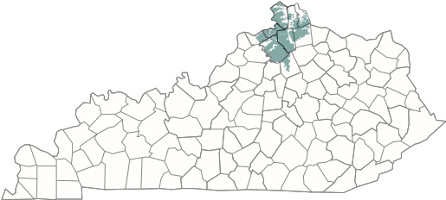
  Boone | Kim Banta  Steven Doan  Mark Hart  Savannah Maddox  Marianne Proctor  T. J. Roberts | Steve Rawlings Gex Williams
  Campbell | Mike Clines Mark Hart | Shelley Frommeyer
  Carroll | Felicia Rabourn | Gex Williams
  Gallatin | Savannah Maddox | Gex Williams
  Grant | Savannah Maddox | Matt Nunn
  Kenton | Kim Banta  Stephanie Dietz  Steven Doan  Mark Hart  Savannah Maddox  Kim Moser | Christian McDaniel Matt Nunn
  Owen | Felicia Rabourn | Gex Williams
  Pendleton | Mark Hart | Shelley Frommeyer
  Scott | Vanessa Grossl Tony Hampton | Matt Nunn
  PENNYRILE ELECTRIC
  Butler | Rebecca Raymer | Stephen Meredith
  Caldwell | Walker Thomas | Craig B. Richardson
  Christian | Myron Dossett  Jason Petrie  Walker Thomas | Craig B. Richardson
  Logan | Jason Petrie | Mike Wilson
  Lyon | Chris Freeland | Jason G. Howell
  Muhlenberg | Rebecca Raymer | Craig B. Richardson
  Simpson | Shawn McPherson | Mike Wilson
  Todd | Jason Petrie | Mike Wilson
  Trigg | Mary Beth Imes Walker Thomas | Jason G. Howell
  COUNTY | REPRESENTATIVE | SENATOR
  SALT RIVER ELECTRIC
  Anderson | James Tipton | Aaron Reed
  Bullitt | Emily Callaway  Peyton Griffee  Thomas Huff | Mike Nemes
  Jefferson | Chris Lewis | Aaron Reed
  LaRue | Ryan Bivens | Jimmy Higdon
  Marion | Michael Pollock | Jimmy Higdon
  Mercer | Kim King | Amanda Bledsoe
  Nelson | Candy D. Massaroni | Jimmy Higdon
  Shelby | Jennifer Henson Decker | Aaron Reed
  Spencer | James Tipton | Jimmy Higdon
  Washington | Kim King | Jimmy Higdon
  SHELBY ENERGY
  Anderson | James Tipton | Aaron Reed
  Carroll | Felicia Rabourn | Gex Williams
  Franklin | Erika Hancock | Gex Williams
  Henry | Felicia Rabourn | Aaron Reed
  Jefferson | John F. Hodgson | Julie Raque Adams
  Oldham | Jason Nemes David Osborne | Lindsey Tichenor
  Owen | Felicia Rabourn | Gex Williams
  Shelby | Jennifer Henson Decker | Aaron Reed
  Spencer | James Tipton | Jimmy Higdon
  Trimble | Felicia Rabourn | Lindsey Tichenor
  SOUTH KENTUCKY RECC*
  Adair | Amy Neighbors | Max Wise
  Casey | Daniel Elliott | Brandon Jackson Storm
  Clinton | Joshua Branscum | Rick Girdler
  Cumberland | Amy Neighbors | Rick Girdler
  Laurel | Shane Baker | Brandon Jackson Storm
  Lincoln | David Meade | Brandon Jackson Storm
*Also serves Tennessee
TO CONTACT LEGISLATORS
EMAIL: legislature.ky.gov • OFFICES: (502) 564-8100 • MESSAGE LINE: (800) 372-7181 • TTY Message Line: (800) 896-0305 • EN ESPAÑOL: (866) 840-6574
COUNTY REPRESENTATIVE |  | SENATOR
SOUTH KENTUCKY RECC (cont.)
McCreary Ken Upchurch |  | Robert Stivers
Shane Baker  Joshua Branscum  Pulaski Josh Bray  David Meade  Ken Upchurch |  | Rick Girdler
Rockcastle Josh Bray |  | Brandon Jackson Storm
Russell Joshua Branscum |  | Rick Girdler
Wayne Ken Upchurch |  | Rick Girdler
TAYLOR COUNTY RECC
Adair | Amy Neighbors | Max Wise
Casey | Daniel Elliott | Brandon Jackson Storm
Cumberland | Amy Neighbors | Rick Girdler
Green | Ryan Bivens | David Givens
Hart | Ryan Bivens | David Givens
Marion | Michael Pollock | Jimmy Higdon
Metcalfe | Amy Neighbors | Max Wise
Russell | Joshua Branscum | Rick Girdler
Taylor | Michael Pollock | Max Wise
TRI-COUNTY EMC*
Adair | Amy Neighbors | Max Wise
Allen | Shawn McPherson | Max Wise
Barren | Steve Riley | David Givens
Clinton | Joshua Branscum | Rick Girdler
Cumberland | Amy Neighbors | Rick Girdler
Metcalfe | Amy Neighbors | Max Wise
Monroe | Amy Neighbors | Max Wise
Warren | Michael Meredith | Mike Wilson
WARREN RECC
Allen | Shawn McPherson | Max Wise
Barren | Steve Riley | David Givens
COUNTY REPRESENTATIVE | SENATOR
WARREN RECC (cont.)
Butler Rebecca Raymer | Stephen Meredith
Edmonson Michael Meredith | David Givens
Grayson Samara Heavrin | Stephen Meredith
Logan Jason Petrie | Mike Wilson
Ohio Scott Lewis | Stephen Meredith
Simpson Shawn McPherson | Mike Wilson
Robert B. Duvall  Warren Kevin JacksonShawn McPherson  Michael Meredith | David Givens  Mike Wilson  Max Wise
WEST KENTUCKY RECC
Calloway Mary Beth Imes | Jason G. Howell
Carlisle Steven Rudy | Danny Carroll
Graves Kimberly Holloway | Jason G. Howell
Hickman Steven Rudy | Jason G. Howell
Marshall Chris Freeland | Danny Carroll
2026 KENTUCKY
ELECTION CALENDAR
April 4 – May 5: Online mail-in absentee request portal open
As of 1/6/2026
April 20: Last day to register to vote for the primary May 6–8 (Wed–Fri) & May 11–13 (Mon–Wed): Excused, in-person absentee voting*
May 14–16: In-person, no-excuse absentee voting
May 19: Primary Election Day • Polls open 6 a.m. to 6 p.m.
Sept. 19 – Oct. 20: Online mail-in absentee request portal open
Oct. 5: Last day to register to vote for the general election Oct. 21–23 (Wed–Fri) & Oct. 26–28 (Mon–Wed): Excused, in-person absentee voting*
Oct. 29–31: In-person, no-excuse absentee voting
Nov. 3: General Election Day • Polls open 6 a.m. to 6 p.m.
*Must have one of the designated reasons to cast a ballot during this period
As of 1/6/2026
*Also serves Tennessee

MEMBER-OWNERS
Jackson Purchase Energy Cooperative Kenergy Corp.
Meade County RECC
TENNESSEE VALLEY AUTHORITY

LOCAL CO-OP PARTNERS
Gibson Electric
Pennyrile Electric
Tri-County EMC
Warren RECC
West Kentucky RECC

MEMBER-OWNERS
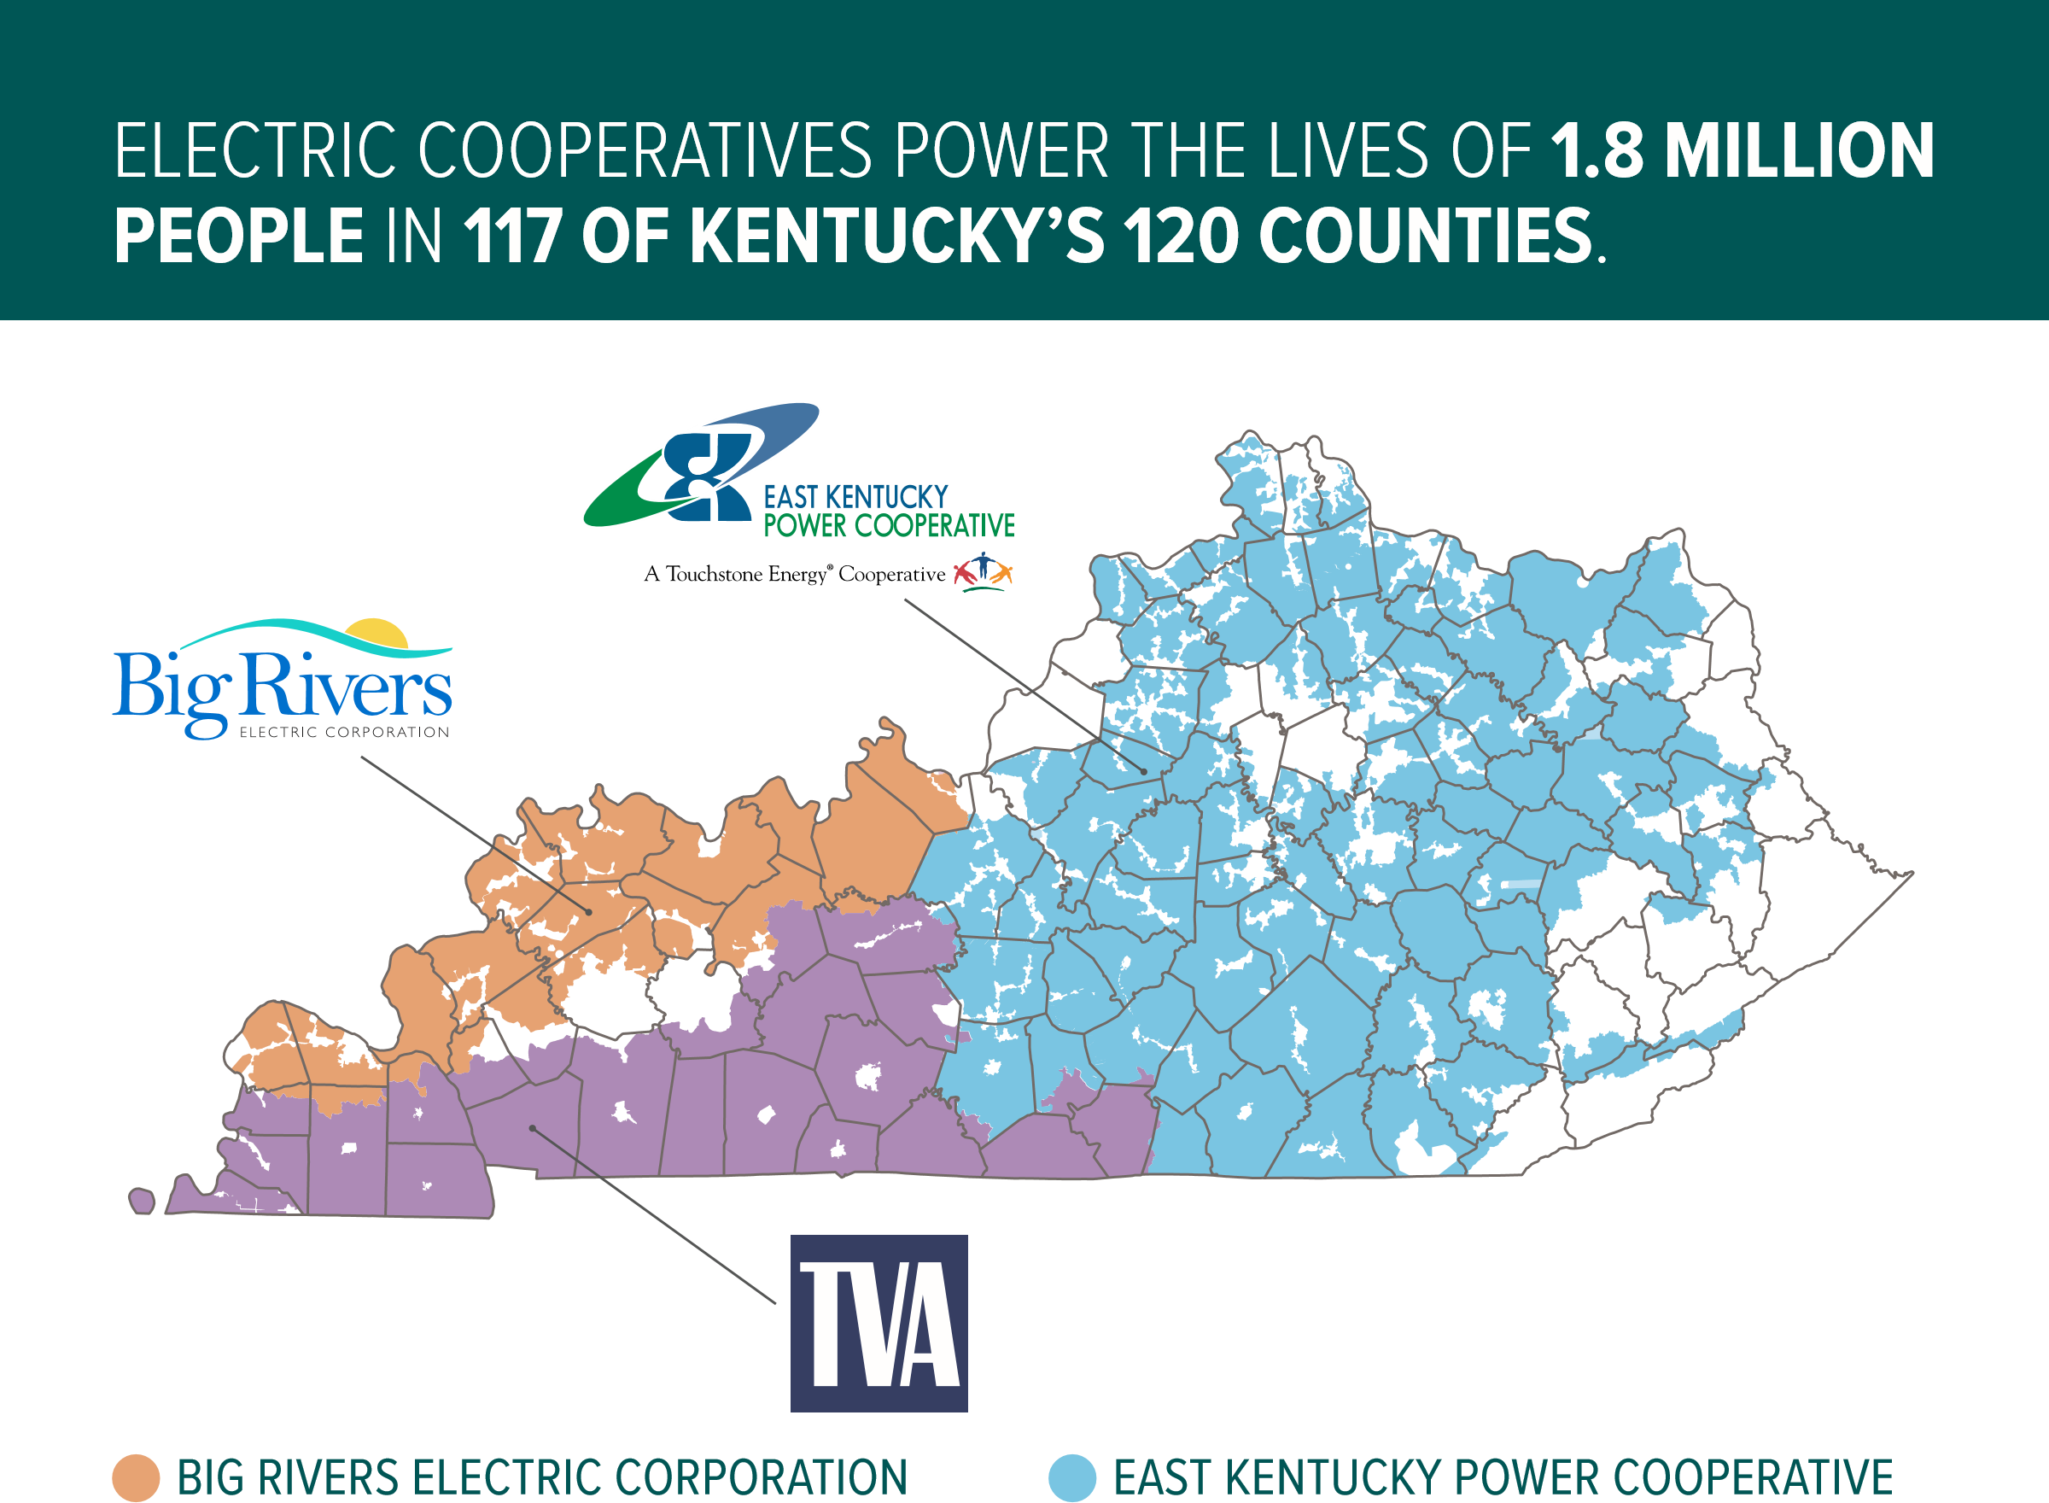
Big Sandy RECC
Blue Grass Energy Cooperative
Clark Energy Cooperative
Cumberland Valley Electric
Farmers RECC
Fleming-Mason Energy Cooperative
Grayson RECC
Inter-County Energy Cooperative
Jackson Energy Cooperative
Licking Valley RECC
Nolin RECC
Owen Electric Cooperative
Salt River Electric Cooperative
Shelby Energy Cooperative
South Kentucky RECC
Taylor County RECC

